PCH I/O kya hai?
I/O = Input / Output
Matlab PCH ke wo pins aur internal circuits jo dusre ICs se data aur signals exchange karte hain.
Simple language me:
PCH I/O = PCH ka Communication Section
Example
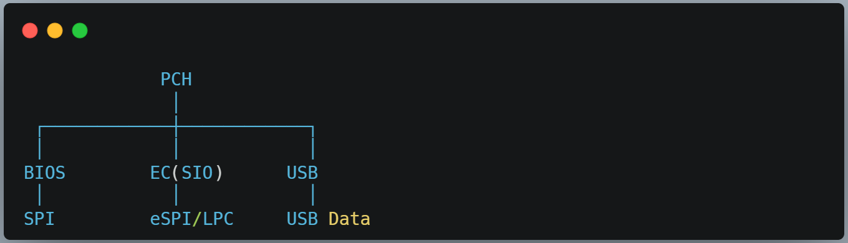

PCH I/O me kya-kya aata hai?
- SPI (BIOS Communication)
- eSPI / LPC (EC Communication)
- SMBus / I²C
- GPIO Pins
- USB Interface
- SATA Interface
- PCIe Interface
Ye sab PCH ke Input/Output circuits hain.
Note:
SPI = Serial Peripheral Interface
Ye ek Serial Communication Protocol (Bus) hai jiske through ek IC dusri IC se high-speed data transfer karti hai.
Motherboard me sabse common use:
PCH ↔ BIOS SPI Flash

Important Note
⚠️ Ye har motherboard me same nahi hota.
- Kuch boards me PCH I/O = 1.8V
- Kuch boards me PCH I/O = 3.3V
- Kuch modern Intel platforms me alag-alag I/O rails hoti hain.
Yahan:
- 1.05V → PCH Core
- 1.8V → PCH I/O
- 3VRTC → RTC Domain
Isliye notes me likha jata hai:

